**ASSIGNMENT-8**

**EXPERIMENT – 14: Write a program that calculates minimum cost to connect n ropes.**

def MinCost(arr, n):

dp = [[0 for i in range(n + 5)]

for i in range(n + 5)]

sum = [[0 for i in range(n + 5)]

for i in range(n + 5)]

for i in range(n):

k = arr[i]

for j in range(i, n):

if (i == j):

sum[i][j] = k

else:

k += arr[j]

sum[i][j] = k

for i in range(n - 1, -1, -1):

for j in range(i, n):

dp[i][j] = 10**9

if (i == j):

dp[i][j] = 0

else :

for k in range(i, j):

dp[i][j] = min(dp[i][j], dp[i][k] +

dp[k + 1][j] + sum[i][j])

return dp[0][n - 1]

arr = [4, 3, 2, 6]

n = len(arr)

print("Minimum Cost to connect n ropes:-")

print(MinCost(arr, n))

**OUTPUT-**

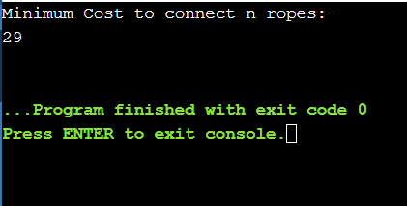

**EXPERIMENT – 15: Write a program to find optimal schedule using assembly line scheduling.**

def carAssembleTime(a, t, e, x):

n = len(a[0])

first = e[0] + a[0][0]

second = e[1] + a[1][0]

for i in range(1, n):

up = min(first + a[0][i],

second + t[1][i] + a[0][i])

down = min(second + a[1][i],

first + t[0][i] + a[1][i])

first, second = up, down

first += x[0]

second += x[1]

return min(first, second)

a = [ [ 4, 5, 3, 2 ], [ 2, 10, 1, 4 ] ]

t = [ [ 0, 7, 4, 5 ], [ 0, 9, 2, 8 ] ]

e = [ 10, 12 ]

x = [ 18, 7 ]

print("Optimal Schedule of carAssembleTime:",carAssembleTime(a, t, e, x))

**OUTPUT-**

